**PROJECT REPORT**

**BUILDING A WEBSITE USING CANVA**

|  |  |
| --- | --- |
| **DATE :** | 25 OCTOBER 2023 |
| **TEAM ID :** | NM2023TMID09051 |
| **TEAM LEAD ID –** SOWMIYA M | 6447B190E1EDF84866049ED77CCD28F4 |
| **TEAM MEMBER 1 ID –** CHRISTINA RACHEL R | AFECEA71A57422A82764556BB299AD69 |
| **TEAM MEMBER 2 ID –** BALAGANAPATHY K | 7B36E57953E1BC5B0A140893B4D09EA3 |
| **TEAM MEMBER 3 ID –** ADHITHIYAN A | 5389A570D8B216C97D5427551F47A430 |
| **PROJECT NAME :** | BUILDING A WEBSITE USING CANVA |

**DEFINE PROBLEM / PROBLEM UNDERSTANDING**

To create a website using CANVA for an offline Store and publish it.

**BRAND NAME:** COOKIES AND CREAM BAKERIES

**CATEGORY:** Butter cookies, Chocolate chip cookies ,flavours of cream

**TARGET AUDIENCE:** ALL (Men, Woman, Youths, Teens, Kids, Babies)

**CANVA WEBSITE URL:**

<https://cookiesandcreambakery.my.canva.site/cookiesandcreambakery>

**DOCUMENTATION:**

**NAVIGATION**

Navigate to[**https://www.canva.com/**](https://www.canva.com/)

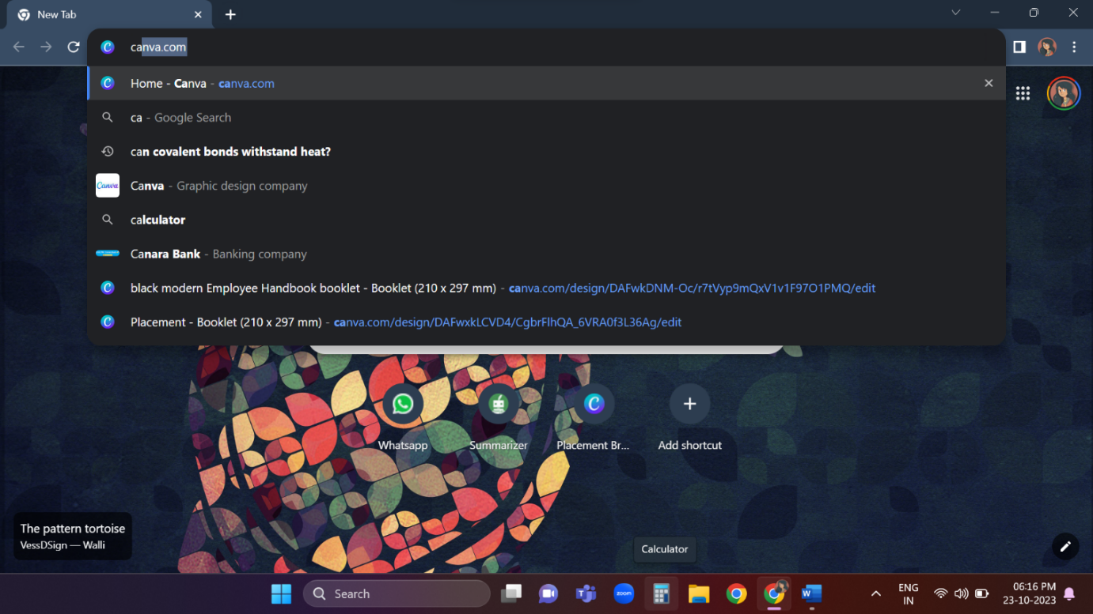

**CREATING DESIGN**

Click "Create a design" As per the picture click on the create design.

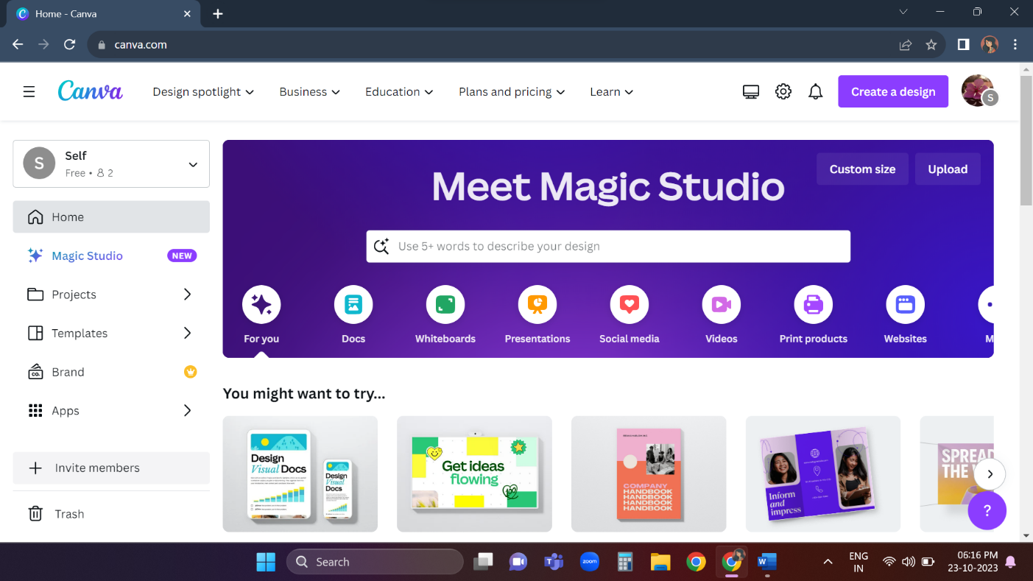

**SEARCH AND CLICK "WEBSITE"**

Search And Click "Website"

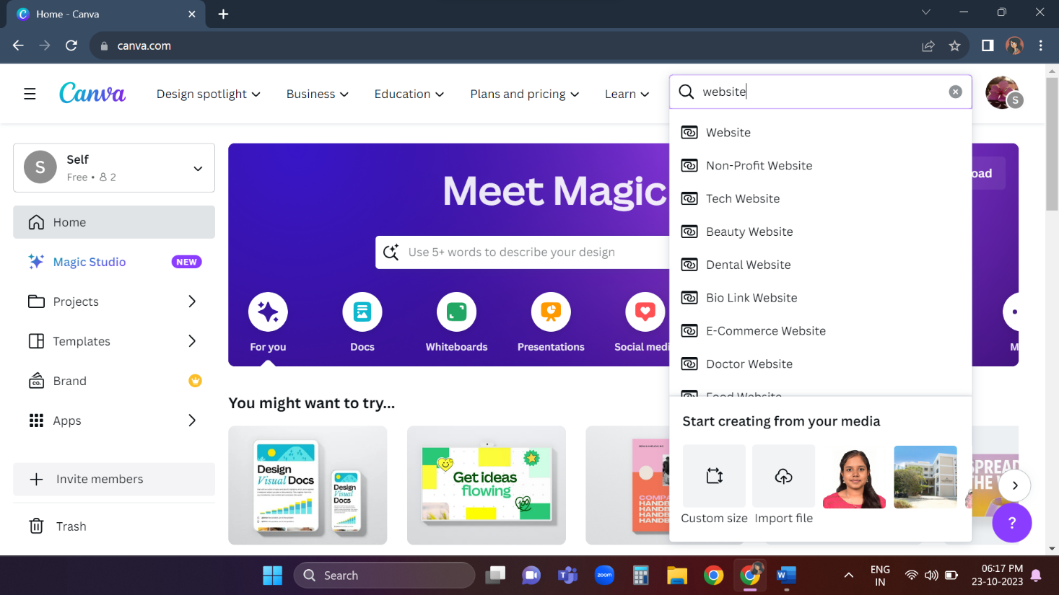

Search And Click "Online Store"

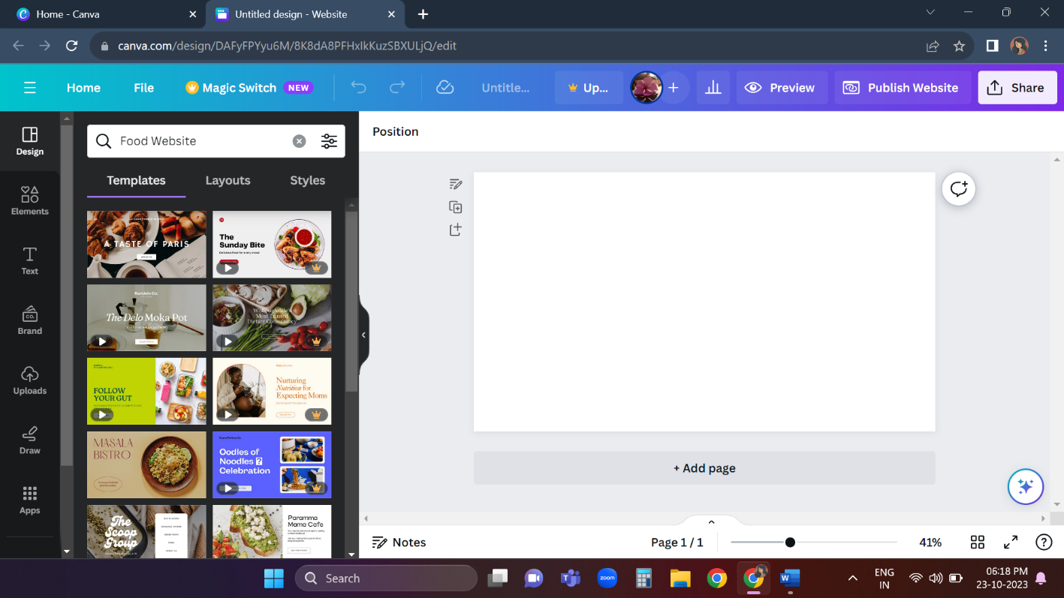

**CHOOSING THE DESIGN**

After entering online store choose a design u like and click on it. select additional templates if you need.

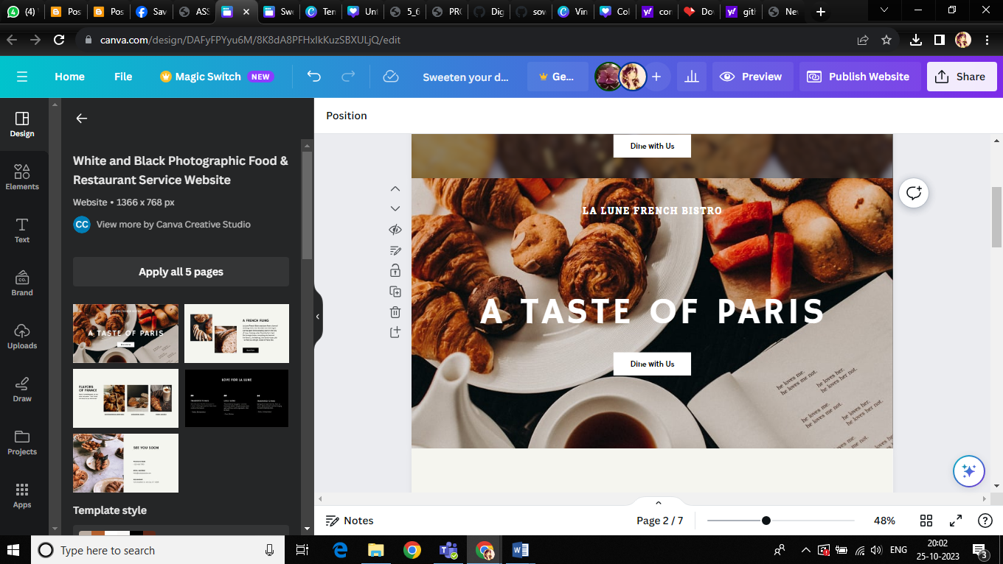

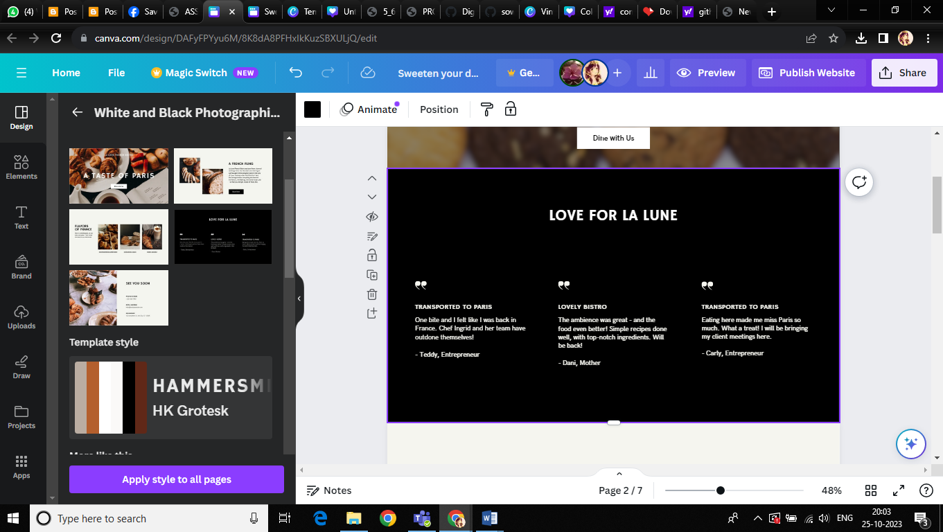

Select "delicious food for every mood" and click duplicate icon and after duplicating it add phone number and place it below order now button.

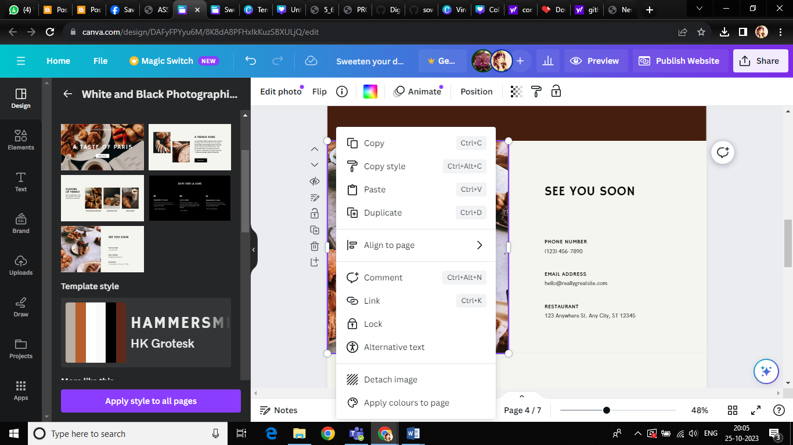

**ADD PHOTOS OR STICKERS**

Add photos or stickers if you need. For that select the page and click the elements on the top of page.

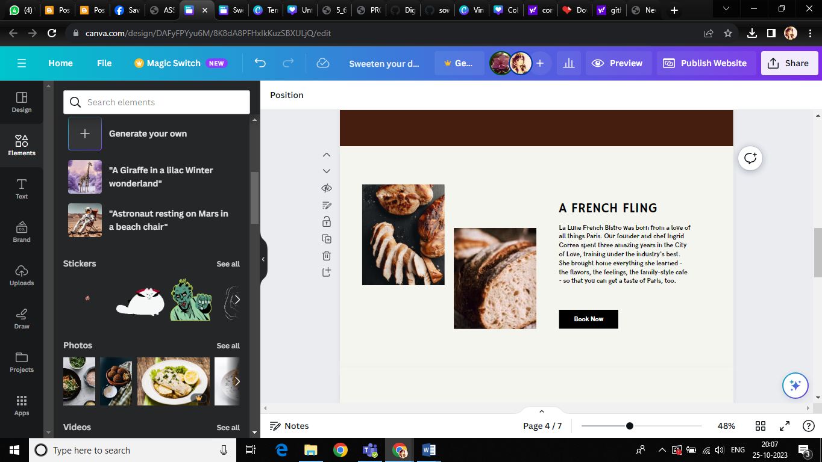

**ADD BRAND FONTS**

Add brand fonts If You Like. Click "Text".

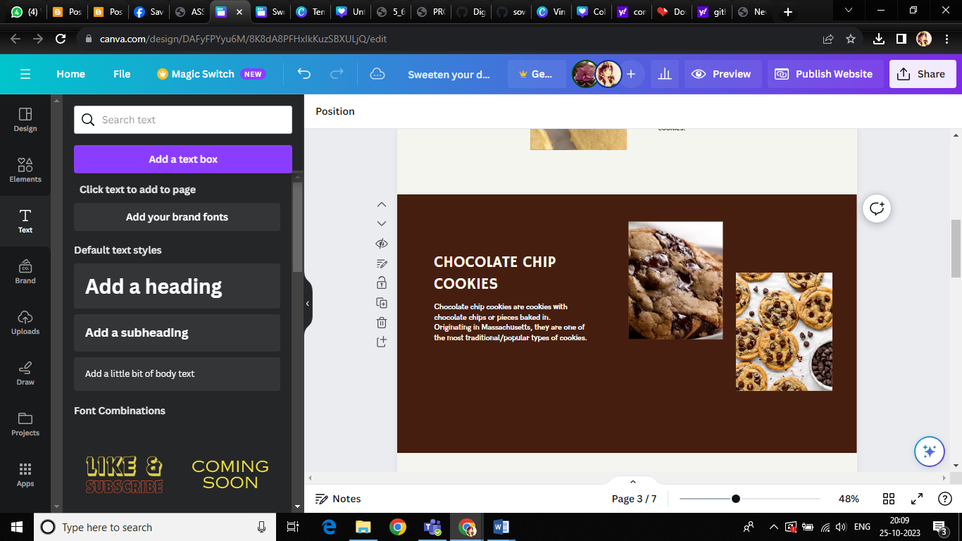

**FINISH EDITING**

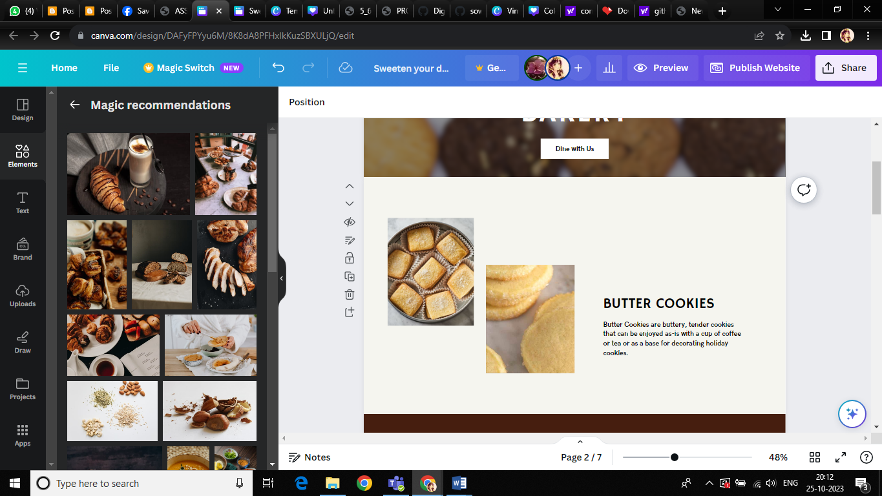

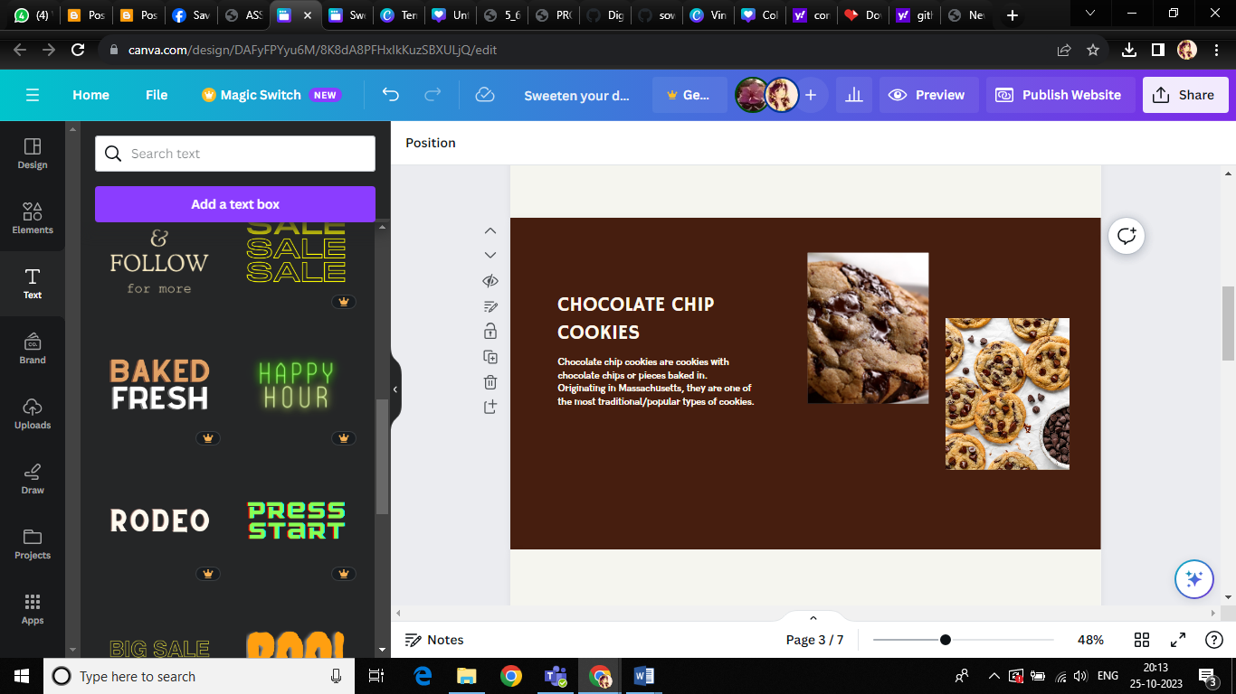

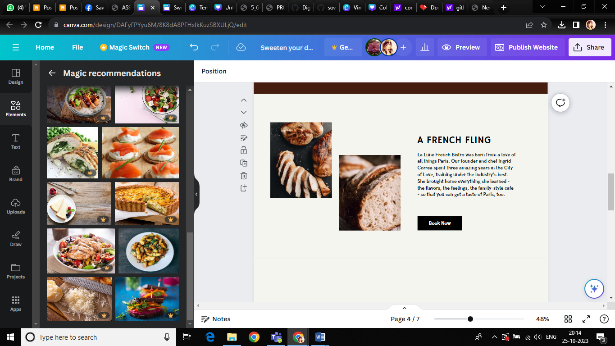

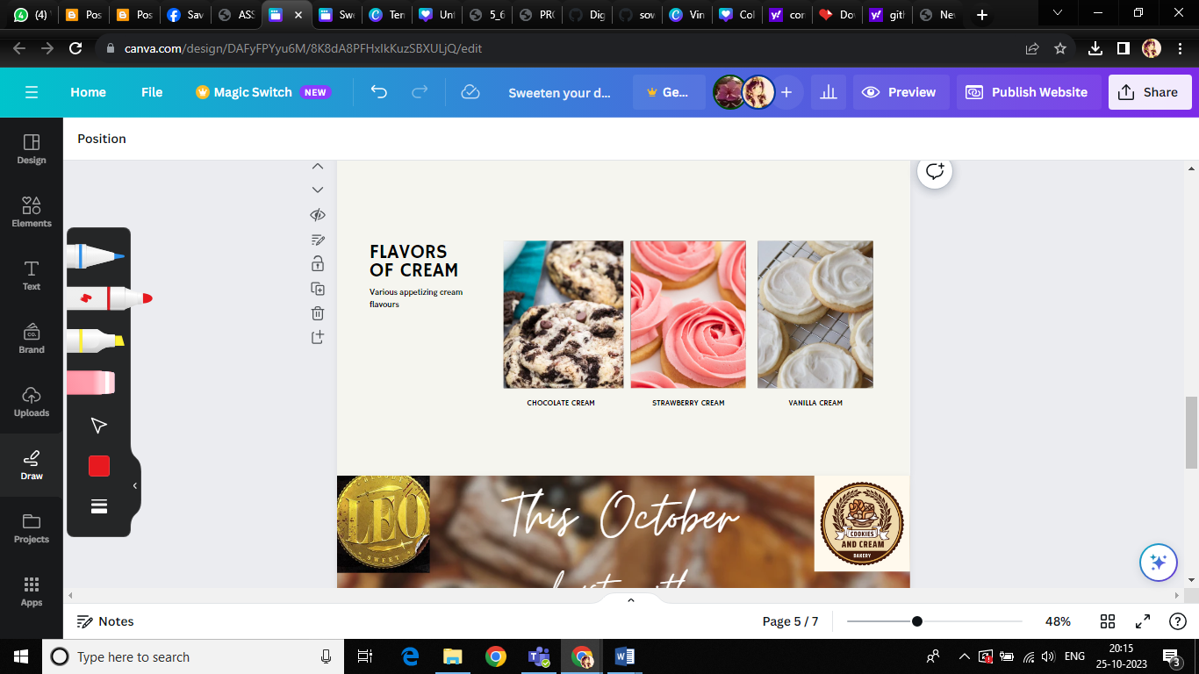

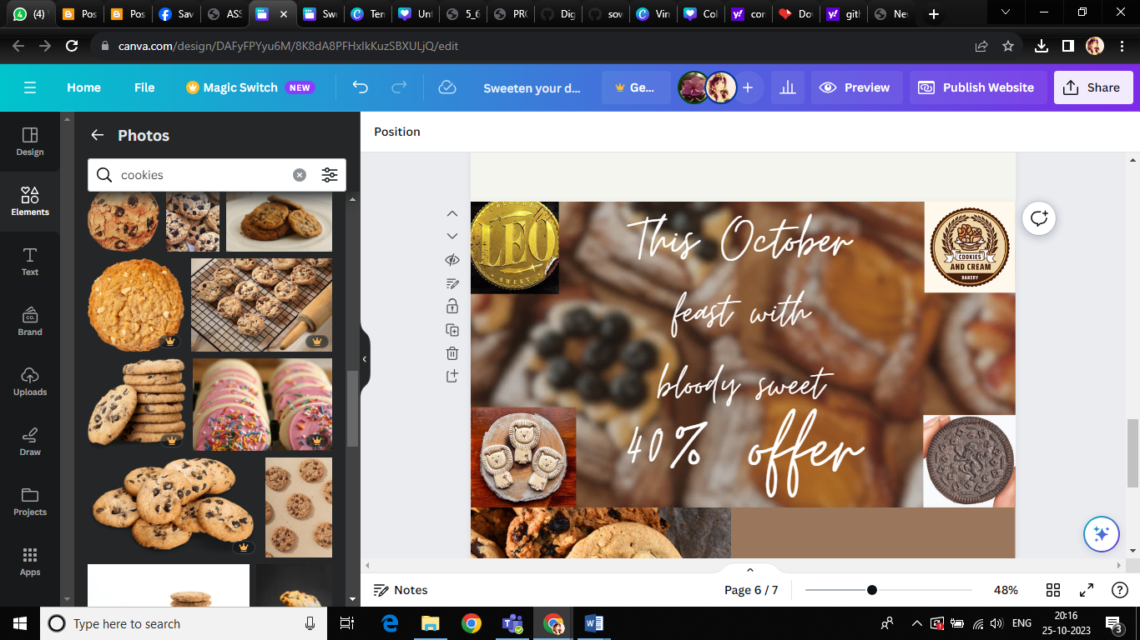

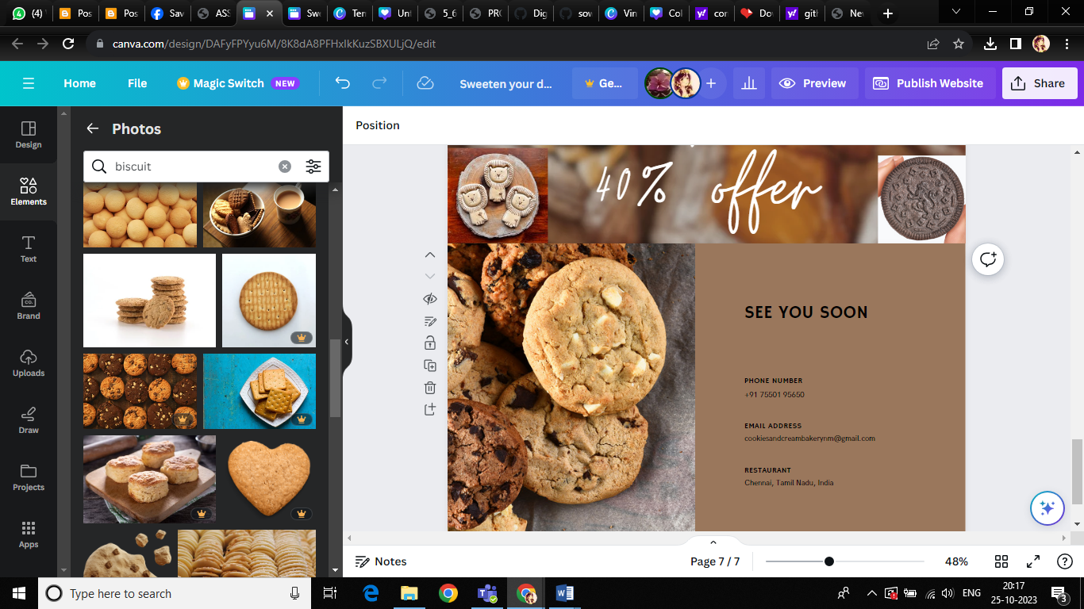

**PUBLISH WEBSITE**

**PUBLISH AND VISIT SITE**

Click Publish

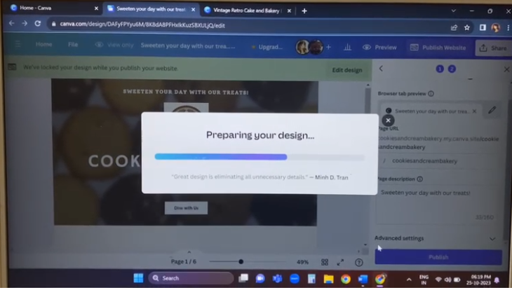

**CLICK "VIEW WEBSITE**

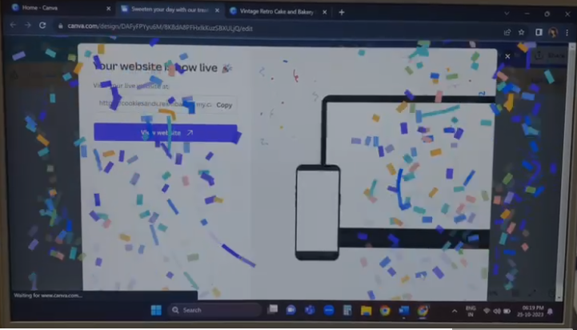

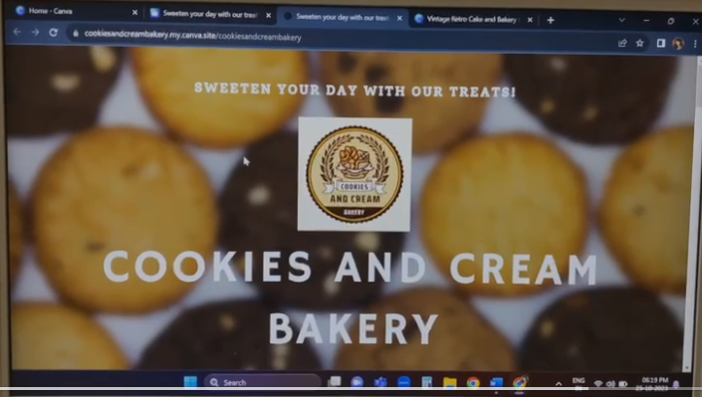

**BRAND NAME:** COOKIES AND CREAM BAKERIES

**CATEGORY:** Butter cookies, Chocolate chip cookies ,flavours of cream

**TARGET AUDIENCE:** ALL (Men, Woman, Youths, Teens, Kids, Babies)

**CANVA WEBSITE URL:** <https://cookiesandcreambakery.my.canva.site/cookiesandcreambakery>

**GitHub LINK:** [**https://github.com/sowmiyamurugan123/DIGITAL-MARKETING**](https://github.com/sowmiyamurugan123/DIGITAL-MARKETING)

**RECORDED VIDEO DRIVE LINK:**

[**https://drive.google.com/file/d/1C4PNYYW4UJnuPcHoBeZ_kbeV4W2OaoUS**](https://drive.google.com/file/d/1C4PNYYW4UJnuPcHoBeZ_kbeV4W2OaoUS)